Samarth Rural Educational Institute’s
Samarth College of Computer Science, Belhe
Academic Year 2026-2027(SEM-V)
T.Y.B.Sc.(Information Technology)
Practical NO:2
Title : 2. Client-Server Architecture and HTTP Communication
Roll NO: 70 Batch : C

Set A
Q1. Demonstrate a GET request using browser and explain the response.
Ans:
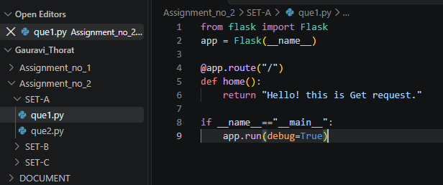
Output:
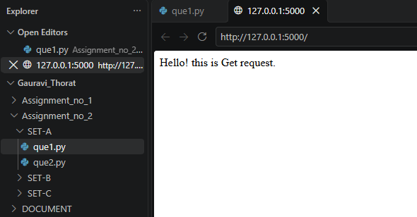
Q2. Create a Flask application displaying "Welcome to Flask".
Ans:
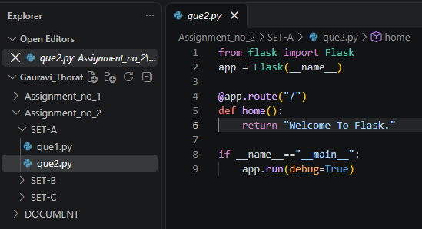
Output:
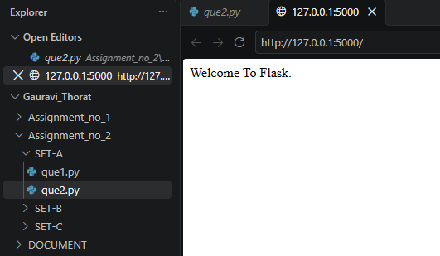

Set B
Q3. Create a Flask application demonstrating POST request using a login form.
Ans:
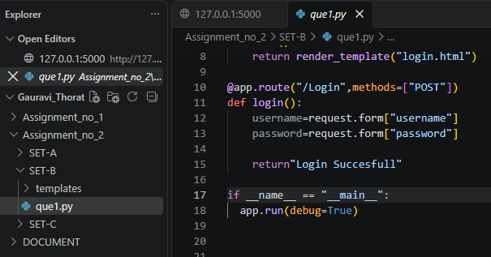
Output:
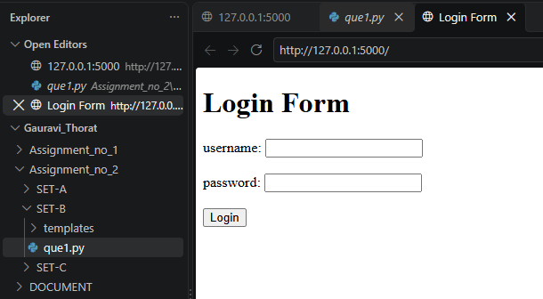

Set C
Q4. Explain the request-response cycle with a practical Flask example.
Ans:
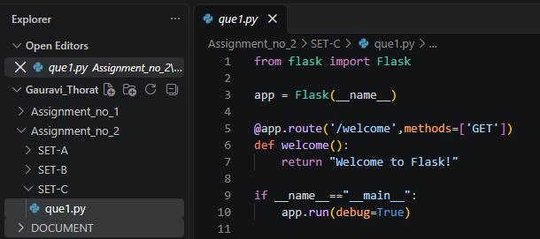

Output:
